Christmas Clearance Sale!

LIMITED STOCK ON HAND

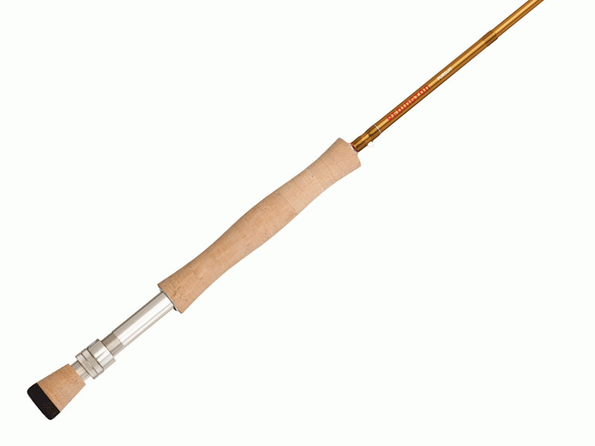

All In Stock Fly Rods 30% off!

Limited Stock On Hand, No Rain Checks

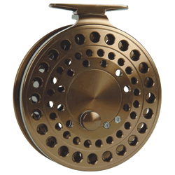

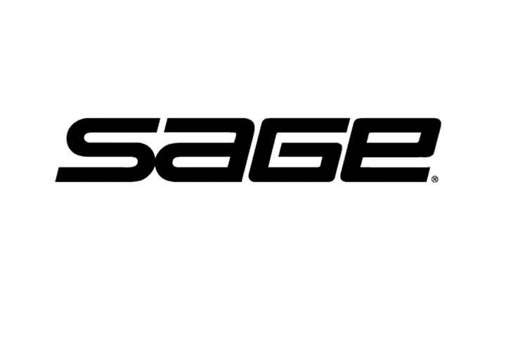
CASTING RODS
CT 3113M -
CT 3106 -
CT 4120 -
CT 4110 -
CT 2106 -

1 only
2 only
2 only
3 only
1 only
Reg. $610.00
Sale $425.00
*Only 7 left
REG. $279.99
SALE $199.99
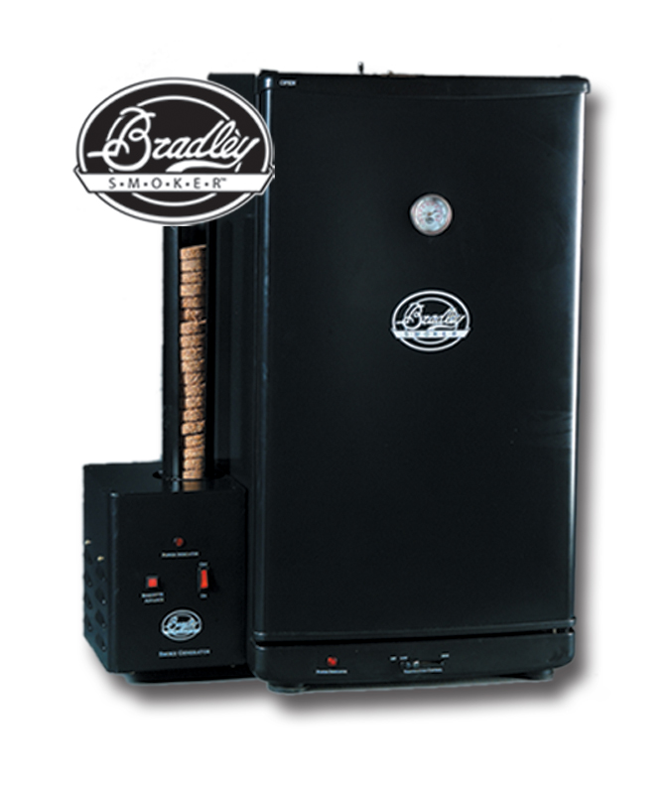
Bradley
Smoker

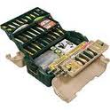
* Only 4 Left
Plano Large 6 Tray Tackle Box
Reg. $56.99
Sale $35.00
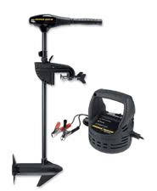
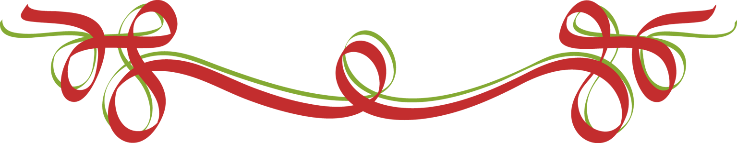

36” 45pd Thrust
Only 3 left
Reg. $389.99
Sale $269.00
BONUS
Free Battery Charger!

Lots of other great prices store wide ! !
SHOP EARLY FOR BEST SELECTION
“LIMITED STOCK ON HAND” NO RAINCHECKS

Okuma Aventa
Center Pin Reel

